**CSE/EEE 120**

**Lab 2 Answer Sheet**

**Multiplexers, Decoders and the Arithmetic and Logic Unit (ALU)**

**Name:** ElHadji Omar Bane

**Instructor/Time:** Doctor Steve @ 10:30 Tuesday & Thursday

**Date:** 2/22/2024

**Task 2-1: Build and Test a 1-Bit 2:1 Multiplexer**

**Please comment on the single biggest issue you were facing when designing the circuit.**

My biggest issue was understanding how a mux would be useful to completing the later tasks.

**Task 2-2: Build a 4-Bit 2:1 Multiplexer**

**Include a picture of your Digital circuit here:**

**Please comment on the single biggest issue you were facing when designing the circuit.**

My biggest issue was structuring the wires so that they were neat.

**Include a picture of your simulation (timing diagram) here:**

**Which tests did you perform and why? Use the following table to describe your test sequence. You need to make sure to perform a sufficient number of tests to check the circuit for eventual faults.**

|  |  |  |
| --- | --- | --- |
| **Test Stimulus** | **Test Motivation** | **Pass/Fail** |
| 2_0_2_1 | Testing a standard situation |  |
| 1_1_2_1 | Testing a standard situation |  |
| F_0_F_0 | Testing extremes when a is 0 and b is high. |  |
| 0_1_F_0 | Testing extremes when a is 0 and b is high. |  |
| 0_0_0_F | Testing extremes when a is high and b is 0. |  |
| F_1_0_F | Testing extremes when a is high and b is 0. |  |
| 7_0_7_7 | Testing when a & b are equal. |  |
| 7_1_7_7 | Testing when a & b are equal. |  |

**Please comment on the single biggest issue you were facing when simulating the circuit.**

My biggest issue was identifying which values needed to be tested and why.

**Task 2-3: Add 7-Segment Displays to Your Circuit**

**Include a picture of your Digital 7-Segment Display here:**

**Please comment on the single biggest issue you were facing when adding the displays.**

The closest thing I can consider an issue for this design was finding a good spot for the displays.

**Task 2-4: Build the NOT/NEG Circuit**

**Include a picture of your Digital circuit here:**

**Please comment on the single biggest issue you were facing when designing the circuit.**

**Task 2-5: Build the AND/ADD Circuit**

**Include a picture of your Digital circuit here:**

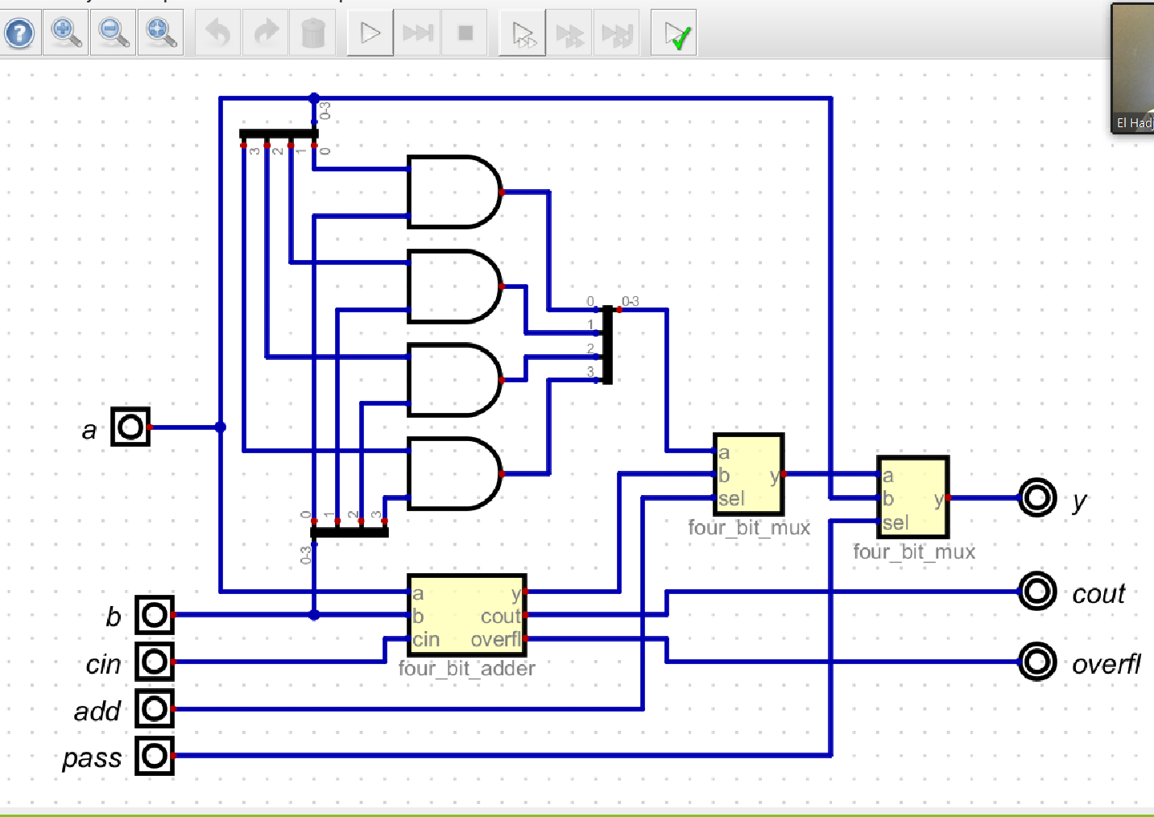

**Please comment on the single biggest issue you were facing when designing the circuit.**

The biggest issue I had was identifying the purpose of the AND gate.

**Task 2-6: Build and Test the ALU Circuit**

**Include a picture of your Digital circuit here:**

**Please comment on the single biggest issue you were facing when designing the circuit.**

The biggest issue I had was comprehending where each wire went and why.

**Please complete the ALU function definition table shown below:**

| arith | invert | pass | Function |
| --- | --- | --- | --- |
| **0** | **0** | **0** | **AND operation, A & B** |
| **0** | **0** | **1** | **Outputs A** |
| **0** | **1** | **0** | **AND operation w/ opposite, A’ & B** |
| **0** | **1** | **1** | **Outputs opposite, A’** |
| **1** | **0** | **0** | **Arithmetic Sum, A+B** |
| **1** | **0** | **1** | **Outputs A** |
| **1** | **1** | **0** | **Arithmetic Sum, -A+B** |
| **1** | **1** | **1** | **Outputs -A** |

**Include all pictures of simulations (timing diagrams) for each function here. With each picture, paste the test_vals from your stimulus file for that test.**

**Did the circuit behave as expected? If no, what was wrong?**

The circuit behave as expected.

**Please comment on the single biggest issue you were facing when simulating the circuit.**

The biggest issue I faced was trying to translate my tests into the stims.

**Task 2-7: Create a video and submit your report**

**Record a short video showing your schematics in Digital and your waveforms in GTKWave. Be sure to show yourself in the video and show your screen. Explain how your circuit works – you need to convince the grader you did the lab and understand it! Copy and paste the link to your video below. Make sure the link is working and pointing to the correct video. Remember to include the password if required. Do NOT upload your video to Canvas. It is recommended that you use Zoom to record to the cloud, pasting the link and password below. If your circuit is not working as expected, explain in the video how it is not working and why you think it is not working.**

**Video Link: https://asu.zoom.us/rec/share/Q-TQi0KPg4EqvNtdST8TPhFpldEvmtPfIMfYs_PBSAOawLdK7BI8P1IrksPlqp1W.TddshAOzaUI6GP49?startTime=1709087399000**

**Passcode: 9k%3JWe?**

**At the beginning of your recording, say your name and the lab name. Be brief in your recording. Submit the completed template to Canvas.**

**Make sure all your files are in the Lab2 directory. Create a zip file of the Lab2 directory. Remember to turn in the zip file and your completed template on Canvas!**

**Do not include the video in the zip file! This makes the file very large and you run the risk of the zip file not uploading or taking so long to upload that your submission will be late. Remember that the submission is dated at the time the upload completes, not when it starts!**

Lab 2: Lab Report Grade Sheet

|  |  |
| --- | --- |
| **Name:** |  |

**NOTE: You submit the zip file in order to show your work.  
If the zip file is not submitted there is a 5 point deduction!**

## Instructor Assessment

| **Grading Criteria** | **Max Points** | **Points Lost** |
| --- | --- | --- |
| **Description of Assigned Tasks, Work Performed & Outcomes Met** |  |  |
| **Task 2-1: Build and Test a 1-bit 2:1 Multiplexer** | **5** |  |
| **Task 2-2: Build a 4-Bit 2:1 Multiplexer** | **5** |  |
| **Task 2-3: Add 7-Segment Displays to Your Circuit** | **5** |  |
| **Task 2-4: Build the NOT/NEG Circuit** | **5** |  |
| **Task 2-5: Build the AND/ADD Circuit** | **10** |  |
| **Task 2-6: Build and Test the ALU Circuit** | **10** |  |
| **Task 2-7: Create a video and submit your report.** | **10** |  |
|  | **Points Lost** |  |
| Lab Score (50 points total) | **Late Lab** |  |
|  | **Lab Score** |  |